  University of Buea | Faculty Of Engineering & Technology
Computer Department | Software Engineering

CEF440 – Internet and Mobile Programming (Task 1)
Task 1: Mobile Application Development Report
Group List
Name | Matricule
Mugha Brayan Aya-ah Ndefru | FE23A097
Ako McPeace Njoh | FE23A009

Github Repository: https://github.com/BrayanMorningstar237/CEF440_Group5

Introduction
Mobile applications are widely used in everyday life for communication, business, and entertainment. This report explains the types of mobile apps, programming languages, frameworks, architecture, requirement engineering, and cost estimation. Tables and examples are included for better understanding.
1. Major Types of Mobile Applications
Mobile apps are grouped based on how they are built and how they run.
Native Apps
Definition: Applications built specifically for a single mobile operating system (iOS or Android) using platform-specific languages like Swift (iOS) or Kotlin/Java (Android).

Key Characteristics:
Performance: Offer the fastest, most fluid experience because they are optimized for the device's hardware.
Access: Have full, deep access to device features like the camera, GPS, Bluetooth, and biometric sensors.
Distribution: Downloaded exclusively from official app stores (Apple App Store or Google Play).
Examples: WhatsApp, Spotify, and Pokémon GO.

Progressive Web Apps (PWA)
Definition: Advanced websites that look and feel like apps, built using standard web technologies (HTML, CSS, JavaScript) and run directly in a mobile browser.
Key Characteristics:
Installation: Users "install" them by adding a shortcut to their home screen directly from the browser; no app store download is required.
Capability: Can work offline and send push notifications (primarily on Android) using "Service Workers".
Updates: Update automatically every time the website is refreshed, ensuring users always have the latest version.
Examples: Starbucks, Pinterest, and Twitter Lite.

Hybrid Apps
Definition: A "blend" of native and web apps. They are essentially web applications placed inside a native container (a "shell") that allows them to be installed like a regular app.
Key Characteristics:
Codebase: Developers write code once using web technologies and package it for both iOS and Android, which is faster and cheaper than native development.
Access: Use "plugins" to bridge the gap between web code and device hardware, allowing access to features like the camera and contacts.
Performance: Typically slower than native apps because they rely on an internal browser view (WebView) to render content.
Examples: Instagram, Gmail, and Uber.

Comparison Table
Type | Description | Advantages | Disadvantages | Example Apps
Native Apps | Built for one platform (Android/iOS) | Very fast, full device access | Expensive, separate codebases | WhatsApp, Instagram
PWA(Progressive Web Apps) | Runs in browser but acts like app | Cheap, cross-platform | Limited hardware access | Twitter Lite
Hybrid Apps | Web app inside native container | One codebase, faster to build | Lower performance | Uber (partly)

2. Mobile App Programming Languages
Different languages are used depending on the platform.
Native Languages
Swift (iOS): The industry standard for Apple devices. It is highly optimized for performance and memory safety. Developers use it to access the latest iOS features immediately, such as advanced AR/VR capabilities for devices like Apple Vision Pro.
Kotlin (Android): Officially preferred by Google for Android development. It eliminates common bugs like null pointer exceptions and is fully interoperable with older Java codebases.
Objective-C & Java: While still used for maintaining legacy systems, they are increasingly being replaced by Swift and Kotlin due to more complex syntax and slower development cycles.
Cross-Platform & Hybrid Languages
Dart (Flutter): Allows developers to create visually rich apps for iOS, Android, web, and desktop from one codebase. It is favored in 2026 for its "Hot Reload" feature, which allows instant UI updates during development.
JavaScript / TypeScript: Powering frameworks like React Native, these languages allow web developers to transition easily to mobile. React Native is often cited as a top choice for startups in 2026 because it delivers near-native performance while saving on development costs.
Kotlin Multiplatform (KMP): An emerging trend where developers use Kotlin to share business logic between iOS and Android while still building separate, fully native UIs for each.
Specialized & Emerging Languages
C++: Still used for performance-critical applications like high-end 3D gaming and real-time AR/VR processing.
Python: While not a "first choice" for mobile UIs, it is essential for the backend logic of modern apps, especially those requiring heavy data analysis or AI-driven features.
Rust: Gaining traction in 2026 for low-level system code and apps requiring extreme memory safety and performance.

Comparison Table

Language | Primary Platform | Key Features | Example Use (Real Apps)
Swift | iOS (Apple) | Fast, secure, modern; optimized for performance; supports latest iOS features (e.g., AR/VR) | Instagram (iOS), Airbnb (iOS)
Kotlin | Android (Google) | Concise, null-safe, modern; official Android language; works with Java | Pinterest (Android), Trello (Android)
Objective-C | iOS (Legacy) | Older Apple language; used in existing apps | Older iOS apps, legacy banking apps
Java | Android (Legacy) | Stable, widely used; now replaced by Kotlin | Older Android apps, legacy enterprise apps
Dart | Cross-platform (Flutter) | Fast UI rendering; Hot Reload; single codebase for multiple platforms | Google Ads, Alibaba
JavaScript | Cross-platform | Flexible; large ecosystem; used in React Native | Facebook, Uber Eats
TypeScript | Cross-platform | Adds type safety to JavaScript; better for large apps | Slack, Asana
C# | Cross-platform (.NET MAUI) | Strong for enterprise apps; Microsoft ecosystem support | Microsoft Teams, Outlook
Kotlin Multiplatform (KMP) | Cross-platform | Share business logic across platforms while keeping native UI | Netflix (partial usage), Cash App
C++ | Cross-platform (Low-level) | Very fast; used for performance-critical features like gaming | PUBG Mobile (game engine parts)
Python | Backend / Cross-platform | Good for AI, data processing, backend services | Instagram (backend), Spotify (data systems)
Rust | Cross-platform (Emerging) | High performance; strong memory safety; modern systems programming | Used in performance modules (emerging apps)

3. Development Frameworks
In 2026, Developers and Engineers choose between native frameworks (best performance) and cross-platform frameworks (faster and cheaper to build). Native apps are still the best for high performance, but tools like Flutter and React Native now give very close results while saving time and cost.
Framework Review
1) Native Frameworks (Swift & Kotlin)
Best For:
Apps that need very high performance, like banking apps, games, or AR/VR apps.
Key Advantage:
Full access to device features like camera, sensors, and latest updates from Apple and Google.
Trade-off:
Expensive and slower to develop because you must build separate apps for Android and iOS.
Real Examples:
- WhatsApp
- Instagram
- Mobile banking apps

2) Flutter
Best For:
Startups, modern apps with custom design, and apps that need to look the same on all devices.
Key Advantage:
Uses its own system to design UI, so apps look consistent on Android and iOS.
Trade-off:
Uses Dart (new language) and app size can be larger.
Real Examples:
- Google Ads
- Alibaba
- BMW app

3) React Native
Best For:
Social media apps, content apps, and teams that already know JavaScript.
Key Advantage:
Large community and many ready-to-use libraries; fast development with hot reload.
Trade-off:
Some complex features may still need native code.
Examples:
- Facebook
- Instagram (partly)
- Uber Eats

4) .NET MAUI
Best For:
Enterprise applications and companies using Microsoft technologies.
Key Advantage:
Uses C# and allows building apps for multiple platforms from one project.
Trade-off:
Smaller community compared to Flutter and React Native.
Examples:
- Microsoft Teams
- Outlook
5) Ionic
Best For:
Simple apps, internal tools, and prototypes.
Key Advantage:
Very easy for web developers (uses HTML, CSS, JavaScript).
Trade-off:
Runs inside a browser (WebView), so performance is lower.
Examples:
- Basic company internal apps
- Simple business dashboards

Framework Use Cases
Use Case | Recommended Framework
Startup MVP (fast & cheap) | React Native / Flutter
High-quality UI app | Flutter
High-performance app | Native (Swift/Kotlin)
Enterprise app | .NET MAUI
Simple web-based app | Ionic

Framework Comparison Table
Feature | Native (Swift/Kotlin) | Flutter | React Native | .NET MAUI | Ionic
Language | Swift, Kotlin | Dart | JavaScript / TypeScript | C# (.NET) | JavaScript / TypeScript
Performance | Excellent | Very High | High | Good | Moderate
Cost & Time | High | Low | Low | Moderate | Very Low
UI/UX | Best (platform standard) | Highly customizable | Native-like | Native-like | Web-based
Complexity | High | Medium | Medium | High | Low
Community | Very Large | Growing fast | Very Large | Medium | Large

4. Mobile App Architecture & Design Patterns
In mobile development, architecture is the structural blueprint of an application, while design patterns are reusable solutions to common problems within that structure. Understanding both ensures that applications are scalable, testable, and maintainable.

Common Mobile Architectural Patterns
These patterns define how data flows between the user interface (UI) and the application logic.
MVC (Model–View–Controller)
- Model: Handles data and business logic
- View: Displays the UI (XML layouts, Storyboards)
- Controller: Connects Model and View
Key Issue:
Controllers often become too large (“Massive View Controllers”), making testing and maintenance difficult.

MVP (Model–View–Presenter)
- The Presenter manages all UI logic
- The View is passive and only displays data
Advantage:
Improves testability because logic is separated from the UI.

MVVM (Model–View–ViewModel) – Modern Standard
- ViewModel: Prepares and manages data for the View
- Data Binding: UI updates automatically when data changes
Why it’s popular:
Widely used in modern development (Android Jetpack, SwiftUI) due to clean separation and reactive behavior.

Architecture Comparison Table
Pattern | Structure | Strength | Weakness | Real App Example
MVC | Controller-based | Simple to start | Hard to scale | Early iOS apps
MVP | Presenter-based | Easy testing | More boilerplate | Legacy Android apps
MVVM | Data-binding | Clean & scalable | Learning curve | Google apps, modern Android

Diagram
a diagram showing MVVM flow:
MVVM architecture diagram mobile app
Model → ViewModel → View
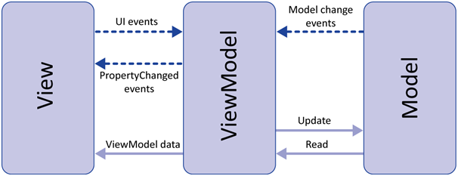
Clean Architecture
Clean Architecture is a layered approach that separates an app into independent components. It is widely used in professional and enterprise-level applications.
Core Layers
- Entities: Core business rules
- Use Cases: Application-specific logic (e.g., user login, fetch profile)
- Interface Adapters: Convert data for UI (ViewModels, Presenters)
- Frameworks & Drivers: External tools (databases, APIs, UI frameworks)

Clean Architecture Structure Table
Layer | Responsibility | Example
Entities | Core logic | User data model
Use Cases | App operations | Login user
Interface Adapters | Data formatting | ViewModel
Frameworks | External systems | API (Retrofit), DB (Room)

Key Benefit
You can change the database or UI framework without affecting the core logic of the app.
Diagram
- Clean Architecture layers diagram Uncle Bob
- Circular/layered structure
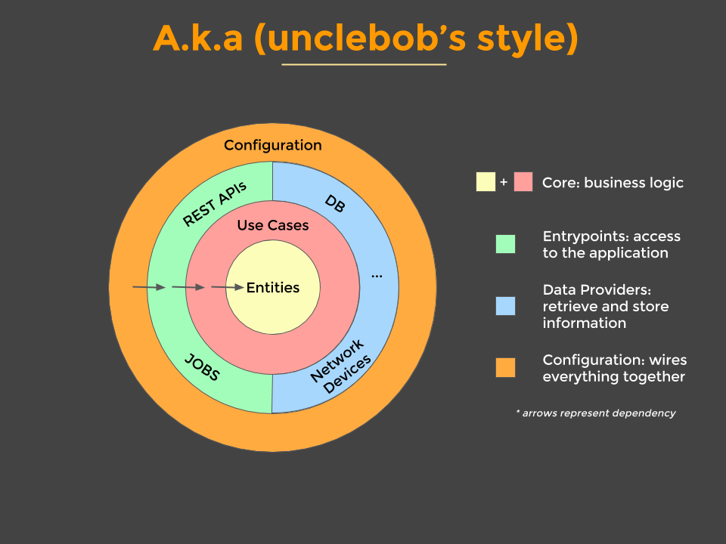
Essential Design Patterns in Mobile Development
These patterns solve specific coding problems within the architecture.
- Common Patterns
- Singleton Pattern
Ensures only one instance exists (e.g., database, user session)
- Observer Pattern
Notifies multiple components when data changes
(Used in LiveData, RxJava, Combine)
- Repository Pattern
Decides whether to fetch data from local storage or remote API
- Dependency Injection (DI)
Provides dependencies from outside instead of creating them internally

Tools Used
Pattern | Tool Example | Platform
Dependency Injection | Hilt / Dagger | Android
Dependency Injection | Swinject | iOS
Observer | LiveData / Flow | Android
Observer | Combine | iOS
Repository pattern Android example diagram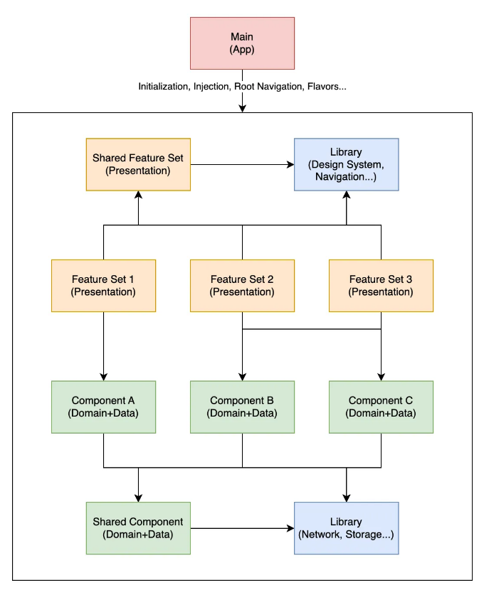
The “Real” Repository Pattern in Android | by Denis Brandi | ProAndroidDev Image
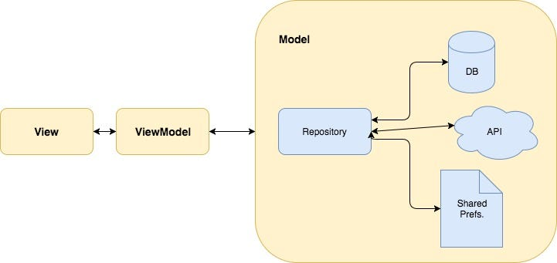
Modern Android development with Kotlin (Part 2) | by Mladen Rakonjac | ProAndroidDev

Dependency Injection mobile app diagram
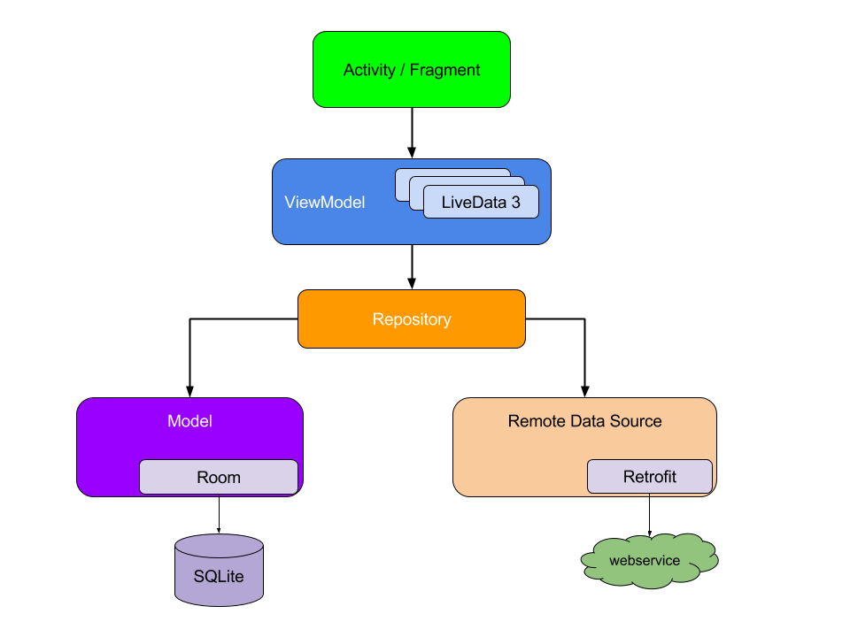
Manual dependency injection | App architecture | Android Developers Image
Architecture Comparison Summary
Pattern | Testing | Complexity | Best Use Case
MVC | Hard | Low | Small apps
MVP | Easy | Medium | Apps with complex UI logic
MVVM | Very Easy | Medium | Modern apps
Clean Architecture | Excellent | High | Large enterprise apps

Why Architecture Matters
Good architecture provides long-term benefits beyond just writing code:
- Scalability: Easy for teams to grow and collaborate
- Maintainability: Changes in one part do not break others
- Reduced Bugs: Clear separation of concerns
- Flexibility: Easier to adapt to OS updates or new technologies

Architectural patterns define the structure of an app, while design patterns solve specific implementation problems. Choosing the right combination improves code quality, simplifies testing, and ensures the app can grow over time.

5. Requirement Engineering in Mobile App Development
Requirement Engineering (RE) is the first and most critical phase of the Software Development Life Cycle (SDLC). In mobile development, this process must consider device limitations (battery, screen size), user mobility, and changing network conditions.
The process is divided into four main stages.
- Requirements Elicitation (Gathering Needs)
This stage focuses on understanding what users and stakeholders actually need.
Techniques Used
- Interviews & Surveys
Ask users directly about problems and expectations
- User Personas
Create fictional users to represent real audiences
- Competitor Analysis
Study similar apps to identify standard and missing features
- Focus Groups
Observe how users interact with apps or prototypes

Examples
Technique | Example
Interviews | A food delivery app like Uber Eats asking users about delivery delays
Personas | “Student Sam” for an e-learning app like Coursera
Competitor Analysis | Comparing WhatsApp vs Telegram features (e.g., file sharing, privacy)
Focus Groups | Testing Instagram UI changes with a group of users

Best Practices
- Talking to real users, and not just assuming
- Focus on user problems, not just features
- Use multiple methods (don’t rely on one source)
Example
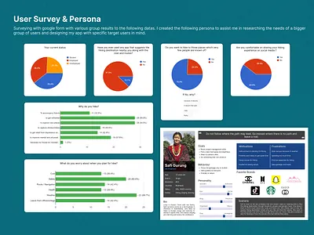
- Requirements Analysis & Categorization
After gathering requirements, they are organized into two types.

Functional vs Non-Functional Requirements
Type | Description | Real Example
Functional (FR) | What the app does | Login with Google (Gmail app)
Functional (FR) | Features provided | Upload photos (Instagram)
Non-Functional (NFR) | Performance | App loads in <2 seconds (YouTube)
Non-Functional (NFR) | Security | End-to-end encryption (WhatsApp)
Non-Functional (NFR) | Offline capability | Spotify offline mode

Best Practices
- Clearly separate “what” vs “how”
- Make requirements measurable (e.g., load time in seconds)
- Prioritize features (Must-have vs Nice-to-have)

- Requirements Specification
This stage converts requirements into structured documents for developers and designers.
Common Techniques
- User Stories
- Use Case Diagrams
- Wireframes / Prototypes

Examples
User Story Example (Instagram):
- “As a user, I want to upload photos so that I can share moments with my followers.”
Use Case Example (Banking App):
- User logs in → checks balance → transfers money
Wireframe Example:
- Sketching login screen before coding (used in apps like Facebook)

Specification Table
Method | Purpose | Example Tool
User Stories | Define features simply | Jira
Use Case Diagram | Show interactions | Draw.io
Wireframes | Design UI flow | Figma, Balsamiq

Best Practices
- Keep user stories simple and clear
- Validate designs before development
- Use visual tools to reduce misunderstandings

Diagram
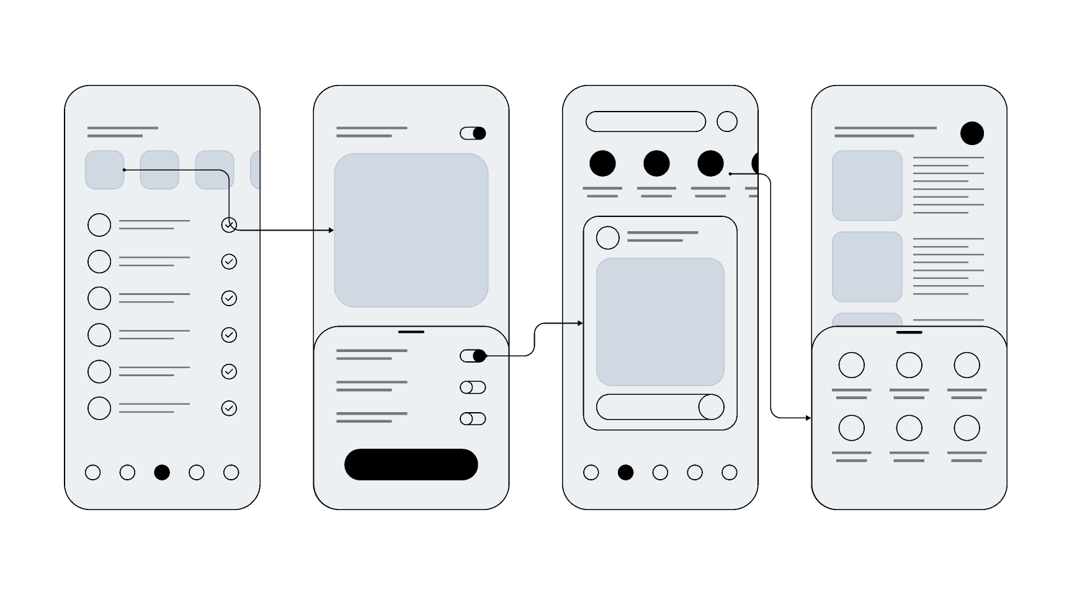
Wireframe “Figma mobile app wireframe example”
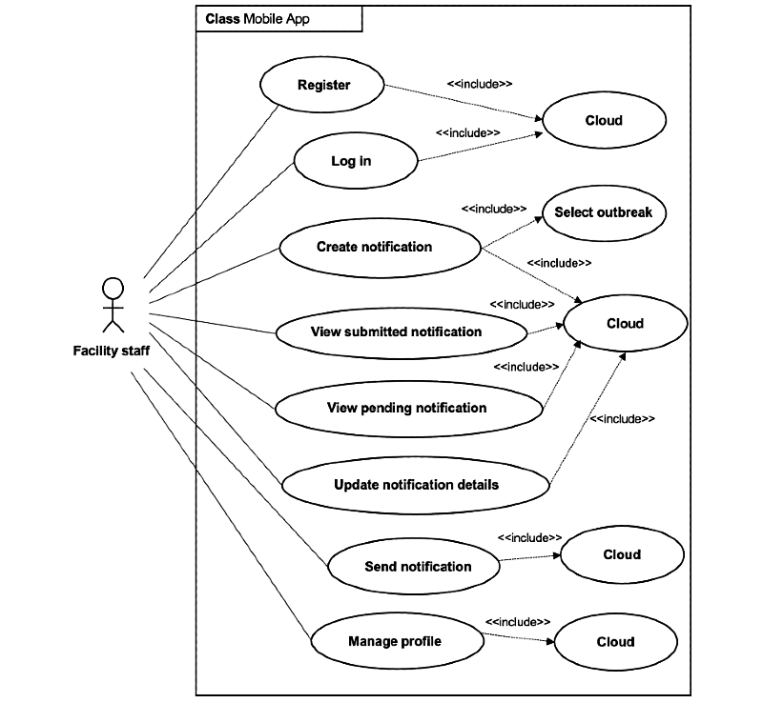
Use Case Diagram “mobile app use case diagram example”

- Requirements Validation & Management
This stage ensures requirements are correct and feasible.

Key Activities
- Feasibility Study
Check if the app can be built with available resources
- Prototyping
Show clickable designs to users
- Traceability Matrix
Track each requirement from idea to implementation

Examples
Activity | Example
Feasibility | Checking if AR filters can run smoothly (Snapchat)
Prototyping | Testing UI changes before release (Airbnb)
Traceability | Tracking features in large apps like Amazon

Best Practices
- Validate early to avoid costly changes later
- Involve users in testing prototypes
- Keep documentation updated
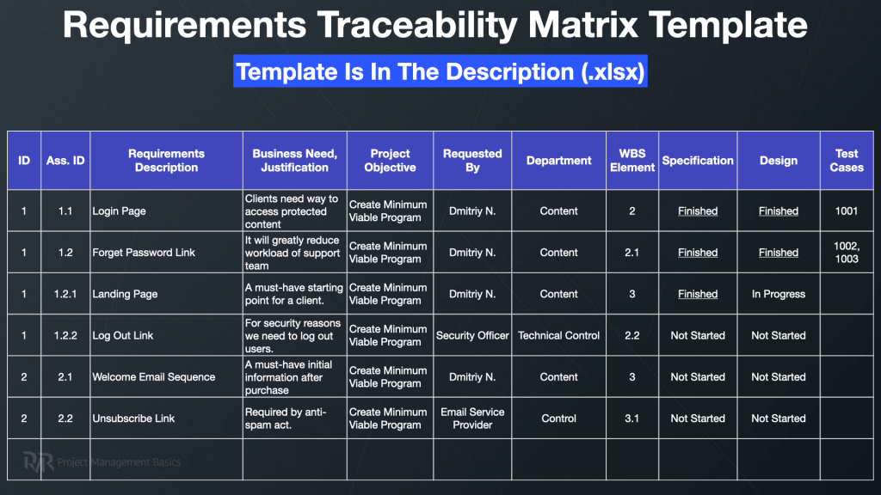
- Prototype → “mobile app clickable prototype example Figma”
- Traceability Matrix → “software traceability matrix example table”

Mobile-Specific Challenges
Mobile apps face unique challenges compared to desktop systems.
Challenges Table
Challenge | Explanation | Example
Context Awareness | Uses location, sensors which may be faulty on some devices | Google Maps using GPS
Connectivity | Works on slow or no internet | WhatsApp offline messages
Device Fragmentation | Different screen sizes/devices | Android apps on phones vs tablets

Best Practices
- Design for offline-first experience
- Optimize for different screen sizes
- Minimize battery and data usage

Summary of Requirement Engineering Process
Phase | Goal | Key Output | Example
Elicitation | Discover needs | Personas, surveys | Uber Eats feedback
Analysis | Organize requirements | FR & NFR list | Instagram features
Specification | Document clearly | User stories, wireframes | Figma designs
Validation | Confirm accuracy | Approved SRS | Airbnb prototype testing

Requirement Gathering ensures that the app solves real user problems and is technically feasible. Using proper techniques, real-world validation, and best practices helps build successful, user-friendly mobile applications.

6. Estimating Mobile App Development Costs (Technical Perspective)
Estimating the cost of a mobile application requires balancing technical complexity, development strategy, and geographic factors. In 2026, typical mobile app costs range from $10,000 to $500,000+, depending on the scale and technical requirements.
Core Estimation Formula
A standard calculation:
Total Cost = Total Development Time (Hours) * Hourly Rate of the Team
Technical Considerations:
- Code Architecture: Using MVVM, Clean Architecture, or Microservices affects development time.
- Third-Party Libraries: Integration of SDKs (payment, maps, analytics) adds hours.
- API Complexity: REST vs. GraphQL or real-time WebSocket connections.
- Device Support: Optimizing for multiple screen sizes and OS versions increases testing time.
Example:
A medium-complexity app with 1,200 development hours at $60/hour:
1,200 X 60 = $72,000
Primary Cost Drivers
App Complexity
Level | Features | Technical Examples | Typical Cost
Simple (MVP) | Basic login, profile, UI | OAuth login, static screens | $10,000 – $100,000
Medium | Custom UI, API integration, payment | Push notifications, payment gateway, analytics SDK | $50,000 – $200,000
High | Real-time data, AI/ML, AR/VR | Machine learning, geolocation tracking, ARKit/ARCore, multi-threaded backend | $100,000 – $400,000+

Technical Implications:
- Real-time features require WebSocket or Firebase RTDB.
- AR/VR requires high GPU optimization and native APIs.
- AI/ML features demand data pipelines and cloud ML services.

Platform Strategy
Strategy | Description | Technical Implications | Cost Impact
Native | Separate iOS & Android codebases | Full access to device APIs, best performance | +20–50%
Cross-Platform | Single codebase (Flutter/React Native) | Limited native API access, faster dev | Reduces cost by 25–40%
PWA | Web-based mobile app | Limited offline/notification capabilities | $10,000 – $90,000

Technical Best Practices:
- Use native development for high-performance apps (games, AR/VR).
- Use cross-platform frameworks for apps with moderate hardware reliance.
- Ensure CI/CD pipelines for automated builds and testing across platforms.

Geographic Location of Developers
Region | Hourly Rate | Technical Impact
North America | $100 – $250 | High expertise in complex architectures
Western Europe | $80 – $150 | Solid backend integration skills
Eastern Europe | $40 – $100 | Cost-effective, experienced in scalable apps
India / SE Asia | $20 – $60 | Budget-friendly, requires strong PM & QA

Technical Best Practices:
- For complex architectures, hire experienced leads locally and offshore devs for implementation.
- Use project management tools (Jira, Trello) to coordinate remote teams efficiently.

Regional Considerations: Africa – Focus on Cameroon
While global development costs vary widely, African countries often provide competitive rates with growing technical expertise, making them an attractive option for startups and SMEs in terms of cost.
Hourly Rates in Africa
Country | Hourly Rate | Notes
South Africa | $35 – $80 | Mature developer ecosystem, strong enterprise experience
Nigeria | $20 – $50 | Fast-growing tech hubs, skilled in mobile and web apps
Kenya | $25 – $55 | Emerging market with good experience in fintech and mobile apps
Cameroon | $15 – $40 | Growing developer community, particularly strong in web and Android development

Technical Implications for Cameroon:
- Talent Pool: Increasing number of trained developers in Flutter, React Native, and Android.
- Infrastructure: Cloud services (AWS, GCP, Azure) are accessible, but connectivity may vary regionally.
- Local Costs: Lower hourly rates reduce total project costs without sacrificing quality if managed well.

Practical Cost Estimation for Cameroon
Scenario: Medium-complexity mobile app (Flutter + Firebase backend) developed in Yaoundé or Douala.
- Estimated Development Time: 1,500 hours
- Hourly Rate (average Cameroon): $25/hour
1,500 x 25 = $37,500
Cost Distribution with Technical Notes:
Stage | Cost | Technical Notes
UI/UX Design (12%) | $4,500 | Wireframes, adaptive design for multiple screen sizes
Frontend Dev (22%) | $8,250 | Flutter widgets, state management, push notifications
Backend Dev (28%) | $10,500 | Firebase backend, Firestore, API integrations, security rules
QA (18%) | $6,750 | Device testing across Android/iOS, automated tests
Maintenance (15%) | $5,625 | Security updates, dependency upgrades, minor feature enhancements
Total First-Year Cost: ~$37,500 + Maintenance

Best Practices for Cameroonian Projects
- Leverage Local Talent: Focus on hiring skilled local developers while outsourcing niche tasks internationally if needed.
- Optimize for Connectivity: Mobile apps in Cameroon should consider offline mode or caching for areas with poor internet.
- Use Cross-Platform Frameworks: Flutter or React Native reduces cost and development time while maintaining performance across devices.
- Infrastructure Planning: Choose cloud providers with regional support and plan for server latency.
- Maintain Technical Documentation: Clearly define architecture, APIs, and dependencies to simplify onboarding new team members.
Local Engineers and Developers Significantly drops the costs

Distribution of Costs by Development Stage
Stage | % of Total Budget | Technical Notes
UI/UX Design | 10–15% | Prototyping (Figma/Balsamiq), responsive design, accessibility compliance
Frontend Development | 20–25% | Screens, animations, state management (Redux/Provider)
Backend Development | 20–30% | REST/GraphQL APIs, database schema, server architecture, microservices for scalability
Testing & QA | 15–25% | Unit, integration, and device testing; automated CI/CD pipelines

Technical Best Practices:
- Ensure modular code for maintainability.
- Include device and OS fragmentation testing.
- Automate performance and security tests.

Hidden and Ongoing Costs
Type | Cost | Technical Implications
Annual Maintenance | 15–20% of initial cost | OS updates, bug fixes, feature enhancements, dependency upgrades
Hosting / Infrastructure | $100 – $10,000+/month | Cloud scalability (AWS, GCP, Azure), load balancing, monitoring, database backups
App Store Fees | $25 (Google), $99/year (Apple) | Publishing, in-app purchase setup, compliance updates

Technical Best Practices:
- Include server scaling costs for growing user base.
- Plan for security patches and compliance (GDPR, HIPAA).
- Monitor API usage costs for third-party services.

Practical Example (Technical)
Scenario: Medium-complexity e-commerce app using Flutter with Firebase backend.
- Development Time: 1,500 hours
- Hourly Rate: $60/hour (Eastern Europe) 1,500 X 60 = $90,000
Cost Distribution with Technical Notes:
Stage | Cost | Technical Notes
UI/UX Design (12%) | $10,800 | Wireframes, accessibility, adaptive design
Frontend Dev (22%) | $19,800 | State management, Flutter widgets, push notifications
Backend Dev (28%) | $25,200 | Firebase backend, Firestore database, cloud functions, API integration
QA (18%) | $16,200 | Automated testing, device testing, CI/CD
Maintenance (15%) | $13,500 | Security updates, dependency upgrades, feature enhancements

Total First-Year Cost: ~$90,000 + Maintenance

Conclusion
Technical considerations are critical for cost estimation:
- Architecture: Clean Architecture, MVVM, or microservices increase upfront cost but reduce long-term maintenance.
- Integrations: Payment gateways, push notifications, analytics, and AI/ML affect time and cost.
- Performance & Security: Optimizations, encryption, offline functionality, and compliance are non-negotiable technical drivers.
- Scalability: Cloud infrastructure and CI/CD pipelines ensure long-term app performance.
Best Practices Summary:
- Start with an MVP and validate features.
- Include technical buffer hours and maintenance cost.
- Distribute budget across stages with technical details for clarity.
- Document all architecture, integrations, and dependencies for accurate cost tracking.

Conclusion: Comprehensive Overview of Mobile App Development Process
Mobile app development is a multi-faceted discipline that requires balancing technical, business, and user-centered considerations. Understanding the differences between native, hybrid, and progressive web apps is fundamental, as the choice directly impacts performance, development cost, and user experience. Native apps excel in speed and device integration, PWAs offer cost-effective web-based solutions, and hybrid apps strike a balance between cross-platform efficiency and moderate performance.
Selecting the right programming language and framework is equally crucial. Languages like Swift and Kotlin provide optimal native performance, while Dart (Flutter) and JavaScript (React Native) enable cross-platform development. Framework selection should consider technical aspects such as runtime performance, UI/UX capabilities, complexity of development, and the maturity of community support, all of which influence the time to market and maintainability.
A solid understanding of mobile app architectures and design patterns ensures that applications are scalable, testable, and maintainable. Patterns like MVC, MVP, MVVM, and Clean Architecture provide structured ways to separate concerns, improve code quality, and reduce long-term maintenance costs. Design patterns such as Singleton, Observer, Repository, and Dependency Injection further enhance code modularity and flexibility, especially in reactive or enterprise-grade applications.
Requirement Engineering (RE) is the cornerstone of successful mobile projects. Proper elicitation, analysis, specification, and validation of both functional and non-functional requirements guarantee that apps address real user needs, account for mobile-specific challenges like connectivity and device fragmentation, and provide clear, actionable documentation for developers. Tools like user personas, wireframes, and traceability matrices are essential best practices that reduce miscommunication and risk.
Finally, accurate cost estimation is critical for planning and resource allocation. Total app cost depends on complexity, platform strategy, geographic location of the development team, and hidden or ongoing costs such as maintenance, hosting, and store fees. For regions like Cameroon, competitive local rates and growing technical talent offer opportunities for cost-efficient development without compromising quality, particularly when leveraging cross-platform frameworks and optimizing for local connectivity and device variations.
In summary, successful mobile app development requires a holistic approach that combines technical proficiency, strategic planning, and user-centric design. Each stage, from app type selection to architecture, requirement engineering, and cost estimation, is interconnected, and careful attention to these factors ensures apps are performant, maintainable, and aligned with user expectations and business goals.

